**Double repeated measures**

**JASP**

**Repeated Measures ANOVA**

| **Within Subjects Effects** | | | | | | | | | | | | | | | | | |
| --- | --- | --- | --- | --- | --- | --- | --- | --- | --- | --- | --- | --- | --- | --- | --- | --- | --- |
|  | | **Sum of Squares** | | **df** | | **Mean Square** | | **F** | | **p** | | **η²** | | **η² p** | | **ω²** | |
| drink |  | 2092 | ᵃ | 2 | ᵃ | 1046.17 | ᵃ | 5.106 | ᵃ | 0.011 | ᵃ | 0.212 |  | 0.212 |  | 0.167 |  |
| Residual |  | 7786 |  | 38 |  | 204.89 |  |  |  |  |  |  |  |  |  |  |  |
| image |  | 21629 | ᵃ | 2 | ᵃ | 10814.34 | ᵃ | 122.565 | ᵃ | < .001 | ᵃ | 0.866 |  | 0.866 |  | 0.856 |  |
| Residual |  | 3353 |  | 38 |  | 88.23 |  |  |  |  |  |  |  |  |  |  |  |
| interaction |  | 2624 |  | 4 |  | 656.11 |  | 17.155 |  | < .001 |  | 0.474 |  | 0.474 |  | 0.444 |  |
| Residual |  | 2907 |  | 76 |  | 38.25 |  |  |  |  |  |  |  |  |  |  |  |
|  | | | | | | | | | | | | | | | | | |
| *Note.*  Type III Sum of Squares | | | | | | | | | | | | | | | | | |
| ᵃ Mauchly's test of sphericity indicates that the assumption of sphericity is violated (p < .05). | | | | | | | | | | | | | | | | | |

R output

|  |  |  |  |  |  |  |
| --- | --- | --- | --- | --- | --- | --- |
| $ANOVA |  |  |  |  |  |  |
| Effect | DFn | DFd | SSn | SSd | F | p |
| 1 (Intercept) | 1 | 19 | 11218.006 | 1920.106 | 111.005411 | 2.25532E-09 |
| 2 drink | 2 | 38 | 2092.344 | 7785.878 | 5.105981 | 0.010862931 |
| 3 image | 2 | 38 | 21628.678 | 3352.878 | 122.564825 | 2.6802E-17 |
| 4 drink:image | 4 | 76 | 2624.422 | 2906.689 | 17.154922 | 4.58904E-10 |

SPSS Output

|  |
| --- |
| **Tests of Within-Subjects Effects** |
| Measure:   MEASURE_1 |
| Source | Type III Sum of Squares | df | Mean Square | F | Sig. | |
| drink | Sphericity Assumed | 2092.344 | 2 | 1046.172 | 5.106 | .011 |
| Greenhouse-Geisser | 2092.344 | 1.154 | 1812.764 | 5.106 | .030 |
| Huynh-Feldt | 2092.344 | 1.181 | 1770.939 | 5.106 | .029 |
| Lower-bound | 2092.344 | 1.000 | 2092.344 | 5.106 | .036 |
| Error(drink) | Sphericity Assumed | 7785.878 | 38 | 204.892 |  |  |
| Greenhouse-Geisser | 7785.878 | 21.930 | 355.028 |  |  |
| Huynh-Feldt | 7785.878 | 22.448 | 346.836 |  |  |
| Lower-bound | 7785.878 | 19.000 | 409.783 |  |  |
| image | Sphericity Assumed | 21628.678 | 2 | 10814.339 | 122.565 | .000 |
| Greenhouse-Geisser | 21628.678 | 1.495 | 14468.490 | 122.565 | .000 |
| Huynh-Feldt | 21628.678 | 1.594 | 13571.496 | 122.565 | .000 |
| Lower-bound | 21628.678 | 1.000 | 21628.678 | 122.565 | .000 |
| Error(image) | Sphericity Assumed | 3352.878 | 38 | 88.234 |  |  |
| Greenhouse-Geisser | 3352.878 | 28.403 | 118.048 |  |  |
| Huynh-Feldt | 3352.878 | 30.280 | 110.729 |  |  |
| Lower-bound | 3352.878 | 19.000 | 176.467 |  |  |
| drink * image | Sphericity Assumed | 2624.422 | 4 | 656.106 | 17.155 | .000 |
| Greenhouse-Geisser | 2624.422 | 3.194 | 821.778 | 17.155 | .000 |
| Huynh-Feldt | 2624.422 | 3.914 | 670.462 | 17.155 | .000 |
| Lower-bound | 2624.422 | 1.000 | 2624.422 | 17.155 | .001 |
| Error(drink*image) | Sphericity Assumed | 2906.689 | 76 | 38.246 |  |  |
| Greenhouse-Geisser | 2906.689 | 60.678 | 47.903 |  |  |
| Huynh-Feldt | 2906.689 | 74.373 | 39.083 |  |  |
| Lower-bound | 2906.689 | 19.000 | 152.984 |  |  |

|  |
| --- |
| **Tests of Between-Subjects Effects** |
| Measure:   MEASURE_1 |
| Transformed Variable:   Average |
| Source | Type III Sum of Squares | df | Mean Square | F | Sig. |
| Intercept | 11218.006 | 1 | 11218.006 | 111.005 | .000 |
| Error | 1920.106 | 19 | 101.058 |  |  |

JAMOVI

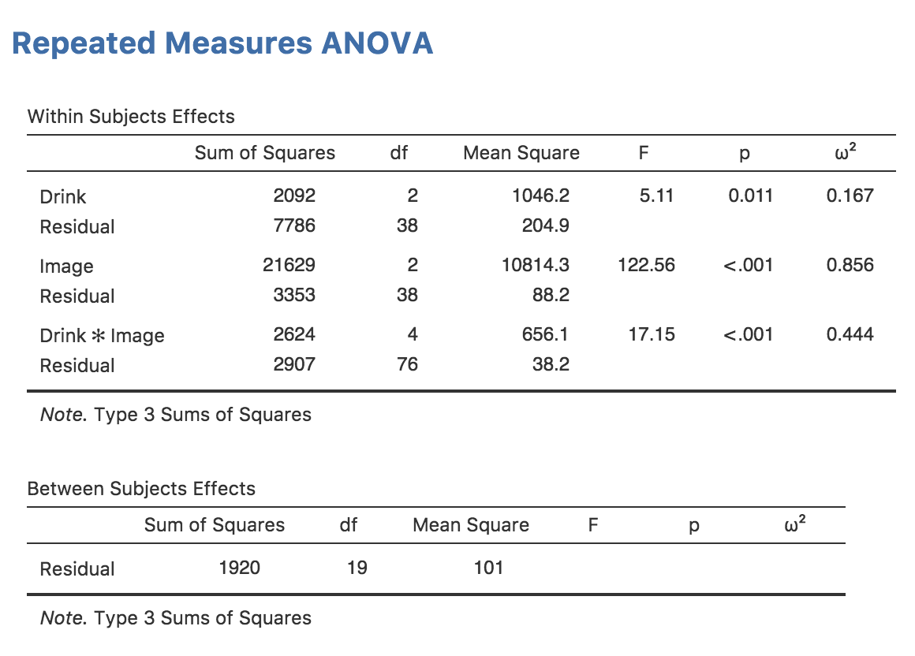

syntax jamovi

jmv::anovaRM(

data=data,

rm=list(

list(

label="Drink",

levels=c("Level 1", "Level 2", "Level 3")),

list(

label="Image",

levels=c("Level A", "Level B", "Level C"))),

rmCells=list(

list(

measure="beerpos",

cell=c("Level 1", "Level A")),

list(

measure="beerneg",

cell=c("Level 1", "Level B")),

list(

measure="beerneut",

cell=c("Level 1", "Level C")),

list(

measure="winepos",

cell=c("Level 2", "Level A")),

list(

measure="wineneg",

cell=c("Level 2", "Level B")),

list(

measure="wineneut",

cell=c("Level 2", "Level C")),

list(

measure="waterpos",

cell=c("Level 3", "Level A")),

list(

measure="waterneg",

cell=c("Level 3", "Level B")),

list(

measure="waterneut",

cell=c("Level 3", "Level C"))),

rmTerms=list(

"Drink",

"Image",

c("Drink", "Image")),

effectSize="omega",

spherCorr="none",

contrasts=list(

list(

var="Drink",

type="none"),

list(

var="Image",

type="none")),

postHocCorr="tukey")

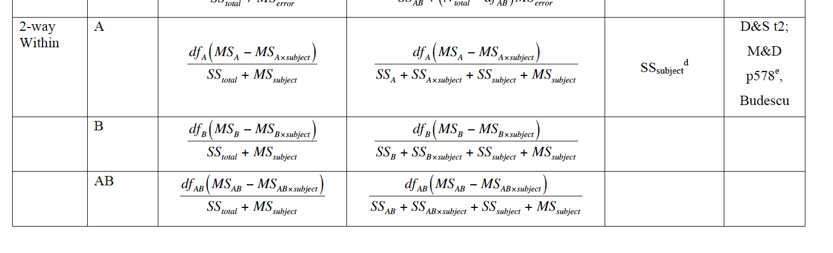

<http://www.skidmore.edu/~hfoley/Handouts/K.Ch18.notes.pdf>

|  |  |  |  |  |
| --- | --- | --- | --- | --- |
| Source | SS | Df | MS | F |
| A | 2092.344 | 2 | 1046.17 |  |
| B | 21628.678 | 2 | 10814.34 |  |
| AXB | 2624.422 | 4 | 656.11 |  |
| S | 1920.106 | 19 | 101.06 |  |
| AXS | 7785.878 | 38 | 204.89 |  |
| BXS | 3352.878 | 38 | 88.23 |  |
| AXBXS | 2906.689 | 76 | 38.25 |  |
| Total | 42310.995 | 179 |  |  |

Where I got the numbers:

SS

* A, B, AXB = ssn or ssm for respective effects
* S = intercept ssd or ssr.p
* AxS, BxS, AXBXS = ssd or ssr for respective effects

Df

* A, B, AXB = dfn or dfm for respective effects
* S = intercept dfd or dfr.p
* AxS, BxS, AXBXS = dfd or dfr for respective effects

Total = sum of all

MS = divide going across

CALCULATING THE A EFFECT:

Omega total: 2 * (1046.17 – 204.89) / (42310.995 + 101.06) = .04

* Ok for real, how the mother eff is JASP getting this .167 number?
* I did some math, and the 42K number is correct for total, so I’m pulling the right things.
* I mathed out what they are including for the total = 9974.13 …

Partial omega: 2 * (1046.17 – 204.89) / (2092.344 + 7785.878 + 1920.106 + 101.06) = .141

CALCULATING THE B EFFECT:

Omega total: 2*(10814.34 - 88.23) / (42310.995 + 101.06) = .51

* For realz though WTF.
* 2*(10814.34 - 88.23) / (24959.94 + 101.06) mathed out

Partial omega: 2*(10814.34 - 88.23) / (21628.678 + 3352.878 + 1920.106 + 101.06) = .79

FUCK ME ARE THEY SAYING TOTAL = SSa + SSaxs?

A total omega = 2 * (1046.17 - 204.89) / (2092.344 + 7785.878 + 101.06) = .169 probs rounding

B total omega = 2*(10814.34 - 88.23) / (21628.678 + 3352.878 + 101.06) = .855

Note at the bottom of the omega document it says this:

SStotal = SSeffect + SSsubject + SSerror (aka SSeffectxsubject)

But that cannot be right: SStotal for A = SSa + SSs + SSaxs that would be equal to partial omega, so maybe that note is for one way designs.

## Mixed Repeated Measures ANOVA

| **Within Subjects Effects** | | | | | | | | | | | | | | | | | | | | | | | | |
| --- | --- | --- | --- | --- | --- | --- | --- | --- | --- | --- | --- | --- | --- | --- | --- | --- | --- | --- | --- | --- | --- | --- | --- | --- |
|  | | | **Sum of Squares** | | | | **df** | | | **Mean Square** | | | | | **F** | | **p** | | **η²** | | **η² p** | | **ω²** | |
| RM Factor 1 | |  | 7744.5 | | |  | 2 | |  | 3872.27 | | | |  | 328.25 |  | < .001 |  | 0.803 |  | 0.948 |  | 0.800 |  |
| RM Factor 1 ✻ Gender | |  | 1473.4 | | |  | 2 | |  | 736.69 | | | |  | 62.45 |  | < .001 |  | 0.153 |  | 0.776 |  | 0.150 |  |
| Residual | |  | 424.7 | | |  | 36 | |  | 11.80 | | | |  |  |  |  |  |  |  |  |  |  |  |
|  | | | | | | | | | | | | | | | | | | | | | | | | |
| Note.  Type III Sum of Squares | | | | | | | | | | | | | | | | | | | | | | | | |
| **Between Subjects Effects** | | | | | | | | | | | | | | | | | | | |
|  | | **Sum of Squares** | | **df** | | **Mean Square** | | | | **F** | | **p** | | **η²** | | **η² p** | | **ω²** | |
| Gender |  | 0.067 |  | 1 |  | 0.067 | |  | | 0.005 |  | 0.946 |  | 0.000 |  | 0.000 |  | 0.000 |  |
| Residual |  | 253.407 |  | 18 |  | 14.078 | |  | |  |  |  |  |  |  |  |  |  |  |
|  | | | | | | | | | | | | | | | | | | | |
| Note.  Type III Sum of Squares | | | | | | | | | | | | | | | | | | | |

R output

|  |  |  |  |  |  |
| --- | --- | --- | --- | --- | --- |
| Effect | DFn | DFd | SSn | SSd | F |
| (Intercept) | 1 | 18 | 282083.2667 | 253.4074 | 20036.89968 |
| Gender | 1 | 18 | 0.06666667 | 253.4074 | 0.004735457 |
| Charisma | 2 | 36 | 7744.533333 | 424.6815 | 328.2497733 |
| Gender:Charisma | 2 | 36 | 1473.377778 | 424.6815 | 62.44868485 |

